Questions to answer next
Please answer these so I can turn this into a real architecture plan:
- What exact start workflow should the app support?
  - one-button start, multi-stage countdown, cues, manual override, or all of these?
There are 2 parts –
Part 1 -set-up
The race office wants to use a selection of flags and timing, from a list. They drag each element into a grid. The sequence of events is based on the grid

This is the race officers screen
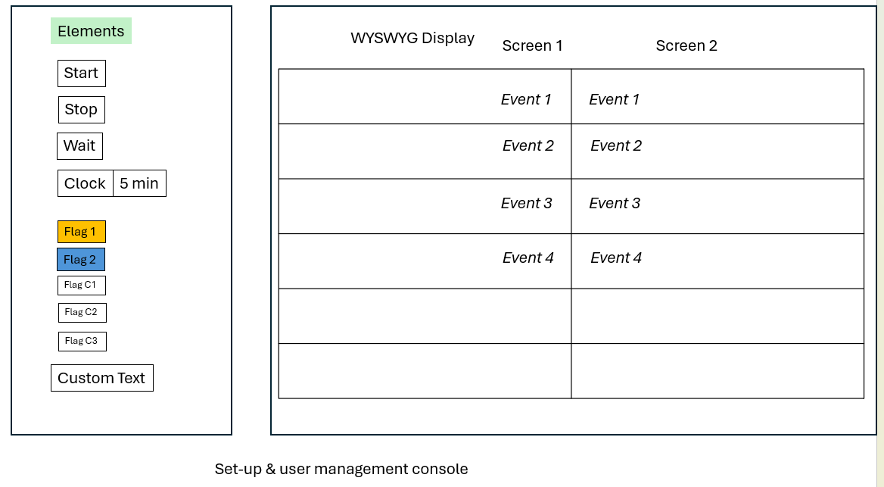As the sequence runs the block running is highlighted

Review https://www.youtube.com/shorts/7H2RZsGK3Jw
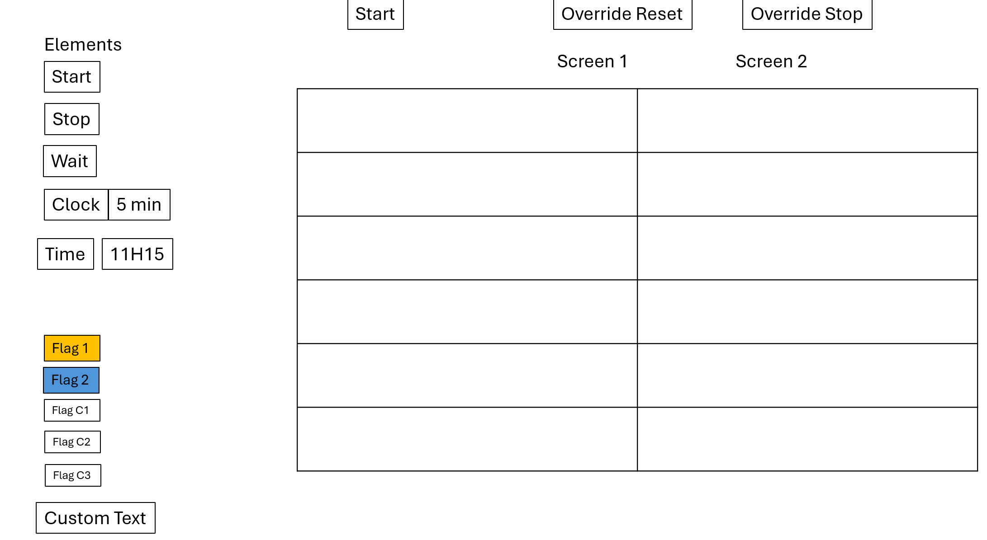
After dragging:

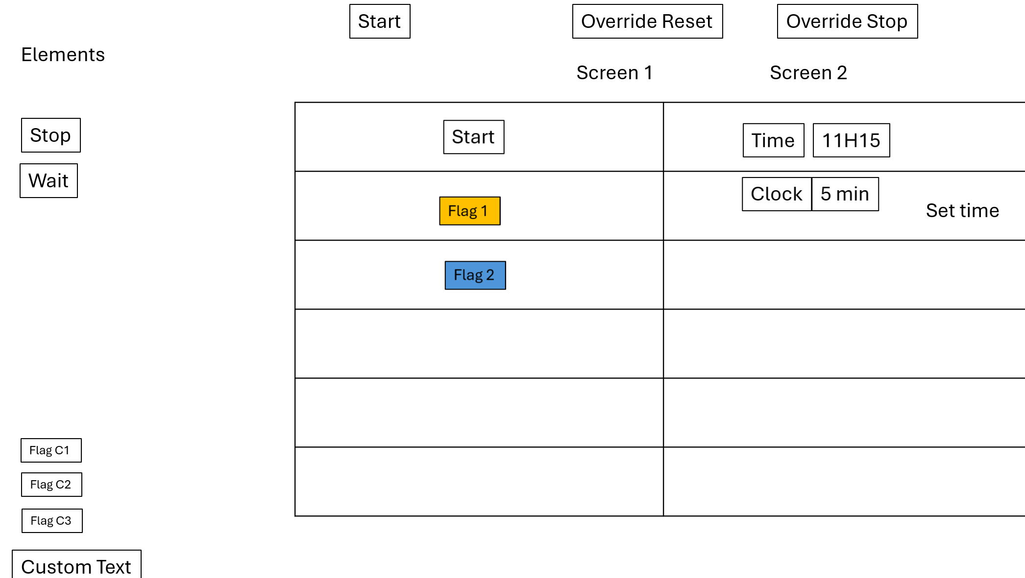
1. Race Officer UI
Touch-screen web application.
Purpose:
- Create race start sequences
- Save templates
- Edit timings
- Re-order steps
- Test sequences
Think:
Plain Text
Toolbox
--------------------------------

Green Flag
Yellow Flag
Blue Flag
Black Flag

Countdown
Delay

Message

--------------------------------

Sequence

[]
[5 Minute Flag]
[Countdown 5:00]
[]
[4 Minute Flag]
[Countdown 4:00]
...

Display board:
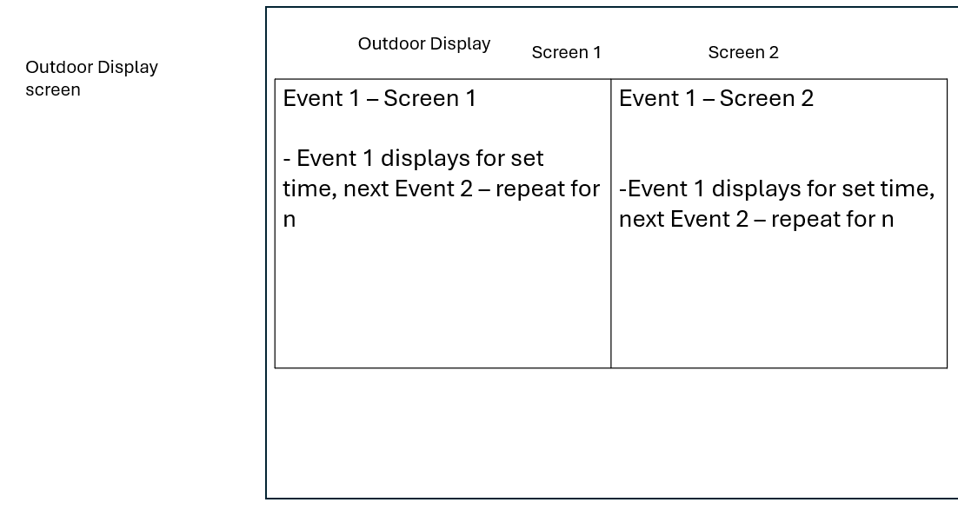

- Is the first version for one race at a time, or should it support multiple saved race templates? – only 1 race, there are multiple classes of boat racing together, typically it is 5 minute from first flag to class 1 start, followed by three minutes till the next class – we have up to 5 classes leaving the start line in 1 race. Once all boats have left the race officer stopr the flag machine, reste when the next race starts later
- Will this run on one screen, or do you want a separate public display for the countdown? The race officer has the control console, and it is a screen share with a display board outside the race tower. ( for now assum is is simply another pc momnitor)
- Do you want a drag-and-drop editor for race stages, or is a form-based setup good enough for v1? Drag and drop is preferred, v1 must be form/dropdown menues
- Are there any required sound cues or external hardware triggers? – not in this version
- Should the interface feel like a modern control dashboard, a race-committee panel, or something more traditional? Very simple design – our race officers want simple big buttons
- Will one operator use it, or do you want a small team workflow with shared control? – 1 operator
- How strict do you need timing accuracy and fail-safe behavior to be? The timing must be linked, when clock 1 for class 1 is complete, clock 2 for class 2 must immediately run, the race officer will have a pause and a stop/reste button. Keep this simple in v1

- Race Configuration System (used by the Race Officer)
- Race Display Engine (used by the outdoor screen)
The key design principle is:
The Race Officer builds a sequence of events. The display engine simply executes the sequence.
Responsibilities:
- Load sequence
- Execute steps
- Maintain clock
- Trigger events
- Maintain state
Example state:
JSON
{
"status": "running",
"currentStep": 4,
"remainingSeconds": 123,
"activeFlag": "yellow"
}
Think of it as a workflow runtime rather than a UI.

4. Outdoor Display
Browser running full-screen.
Display receives state updates.
Shows:
Plain Text
----------------------
5:00
----------------------

[WARNING FLAG]

NEXT SIGNAL:
4 MINUTE FLAG
Show more lines
The display should contain no business logic.
It only renders state coming from the engine.



1. The Sub-Sequence Milestone Rules

to be clear - due to many variables the flag system was designed to be highly flexible. I would like the race officer to be able to drag the flag order and class order into the event block and the timer is independent of the flag type/colour. For version 1 – once the race starts with the Start time no further edits will take place until the final count down is finished
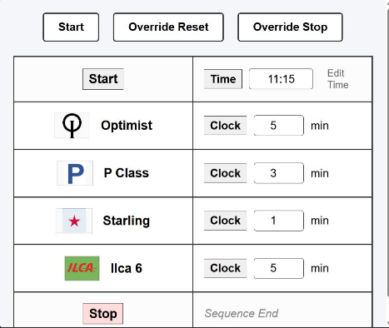
be running
The timers are daisy chained and run one after each other. Timers are independent of the image file on the left side of the event box
Event box/row 1
Event box 2

In standard racing systems, flags are displayed and removed at precise minute marks within a single class's countdown block. For a standard 5-minute event (like Ilca 6), does your sequence follow this pattern: - we would like to flex and allow the race officer to place the flags and classes in the sequence – flags are independent of the counter

Below is a typical flow,

5 Minutes Remaining: Class Flag goes UP (Warning signal)

4 Minutes Remaining: P Flag goes UP (Preparatory signal)

1 Minute Remaining: P Flag comes DOWN (1-minute notification)

0 Minutes (Start): Class Flag comes DOWN (Race Start / Gun)

If yes, how do these milestones compress for your shorter classes? For instance, your data model contains a 3-minute class (Starling) and a 1-minute class (P Class). When do their respective Class, P, and D flags trigger? At our club atypical sequence is as the Ilcal fleet starts (after 5 mins) – starling flag goes up – 3 minutes to start, at 2 minutes the P (blue peter flag goes up) 1 minute P goes down, on start Starling flag down, next class immediately up – this is the typical order and the app we build will allow the race officer to get it set-up with the sequence he want for the days wind conditions, class handicaps etc. as the time and flag are independent the race officer sets the order and how long to count down

2. The Scope of the "D Flag"
How does the D Flag behave relative to the active sequence clock? – let igonr the D flag for now

Is it a global flag? (e.g., Raised once at the beginning of the entire regatta to signal "boats can leave the beach/harbor", remaining visible across all classes?) – yes this is a signal that w=the conditions are ok and get out onto the water – its not implicitly connected to the timing of the start – let ignore E flag

3. UI Display Layout
Our current backend data model assigns exactly one unique flag_image string per boat class row. To display multiple flags (Class flag, P flag, D flag) simultaneously as the clock ticks down, how would you like them arranged on screen? – make a library on a new left column, then race officer drags the ones he wants into the event grid

Option 1 (Single Dynamic Box): A single large flag preview frame per row that swaps its image automatically based on the active milestone (e.g., shows the Class flag at 5m, swaps to show the P flag at 4m, etc.).

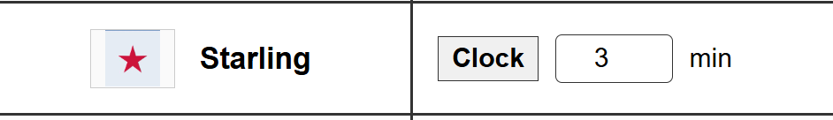
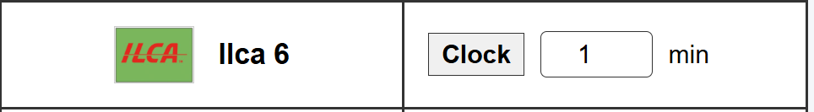
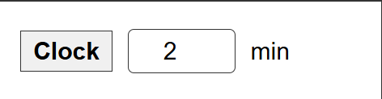
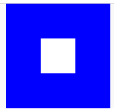
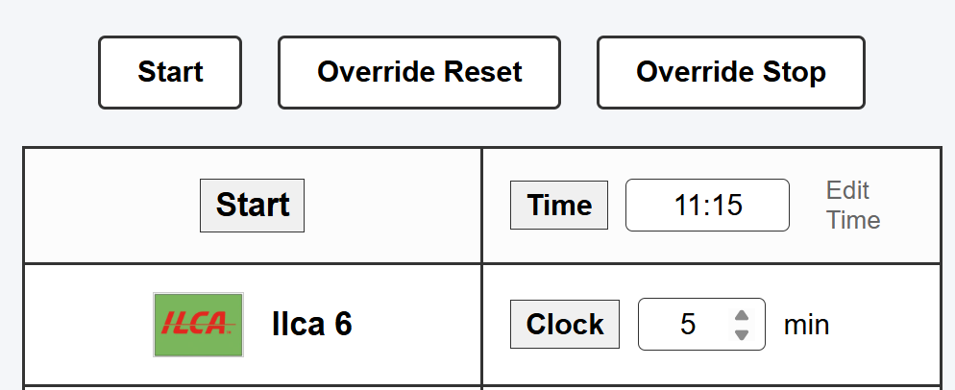
Hidden – the ilca race start – the flag goes down and the Starling goes up

P (blue peter – 2 minutes
Starling - 1 minute
(0 mins race starts and the sequence for next class)
In this version make a red outline around the event box

